W. D. Hartley Elementary School
SAC meeting
4 November 2025
Minutes

The meeting was called to order by Principal Nikki Appelquist due to the absence of Ms. Amber Kerly, SAC Chair, at 3:01 p.m.
Members Present:
Members absent:

- SAC Business
- Approval of October 7, 2025, Minutes
Racheal McKenny moved to approve the minutes as submitted, Becky Cromwell seconded the motion. The minutes were unanimously approved.
- SAC Budget: Unchanged from last meeting

- Principal’s Report
- School Improvement Plan (SIP)
Ms. Appelquist presented an update of the Hartley 2025-2026 SIP.

Slide 1:
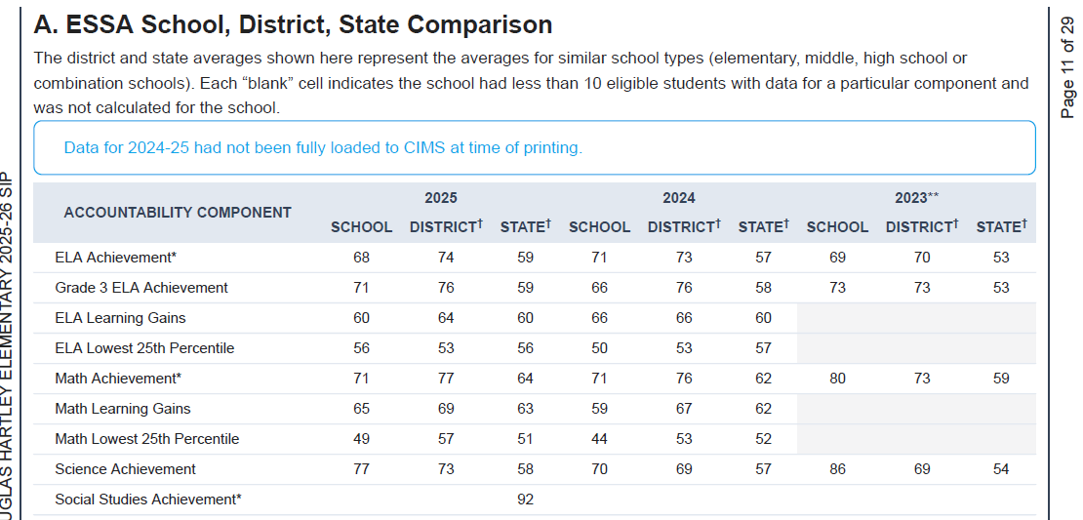

Slide 2
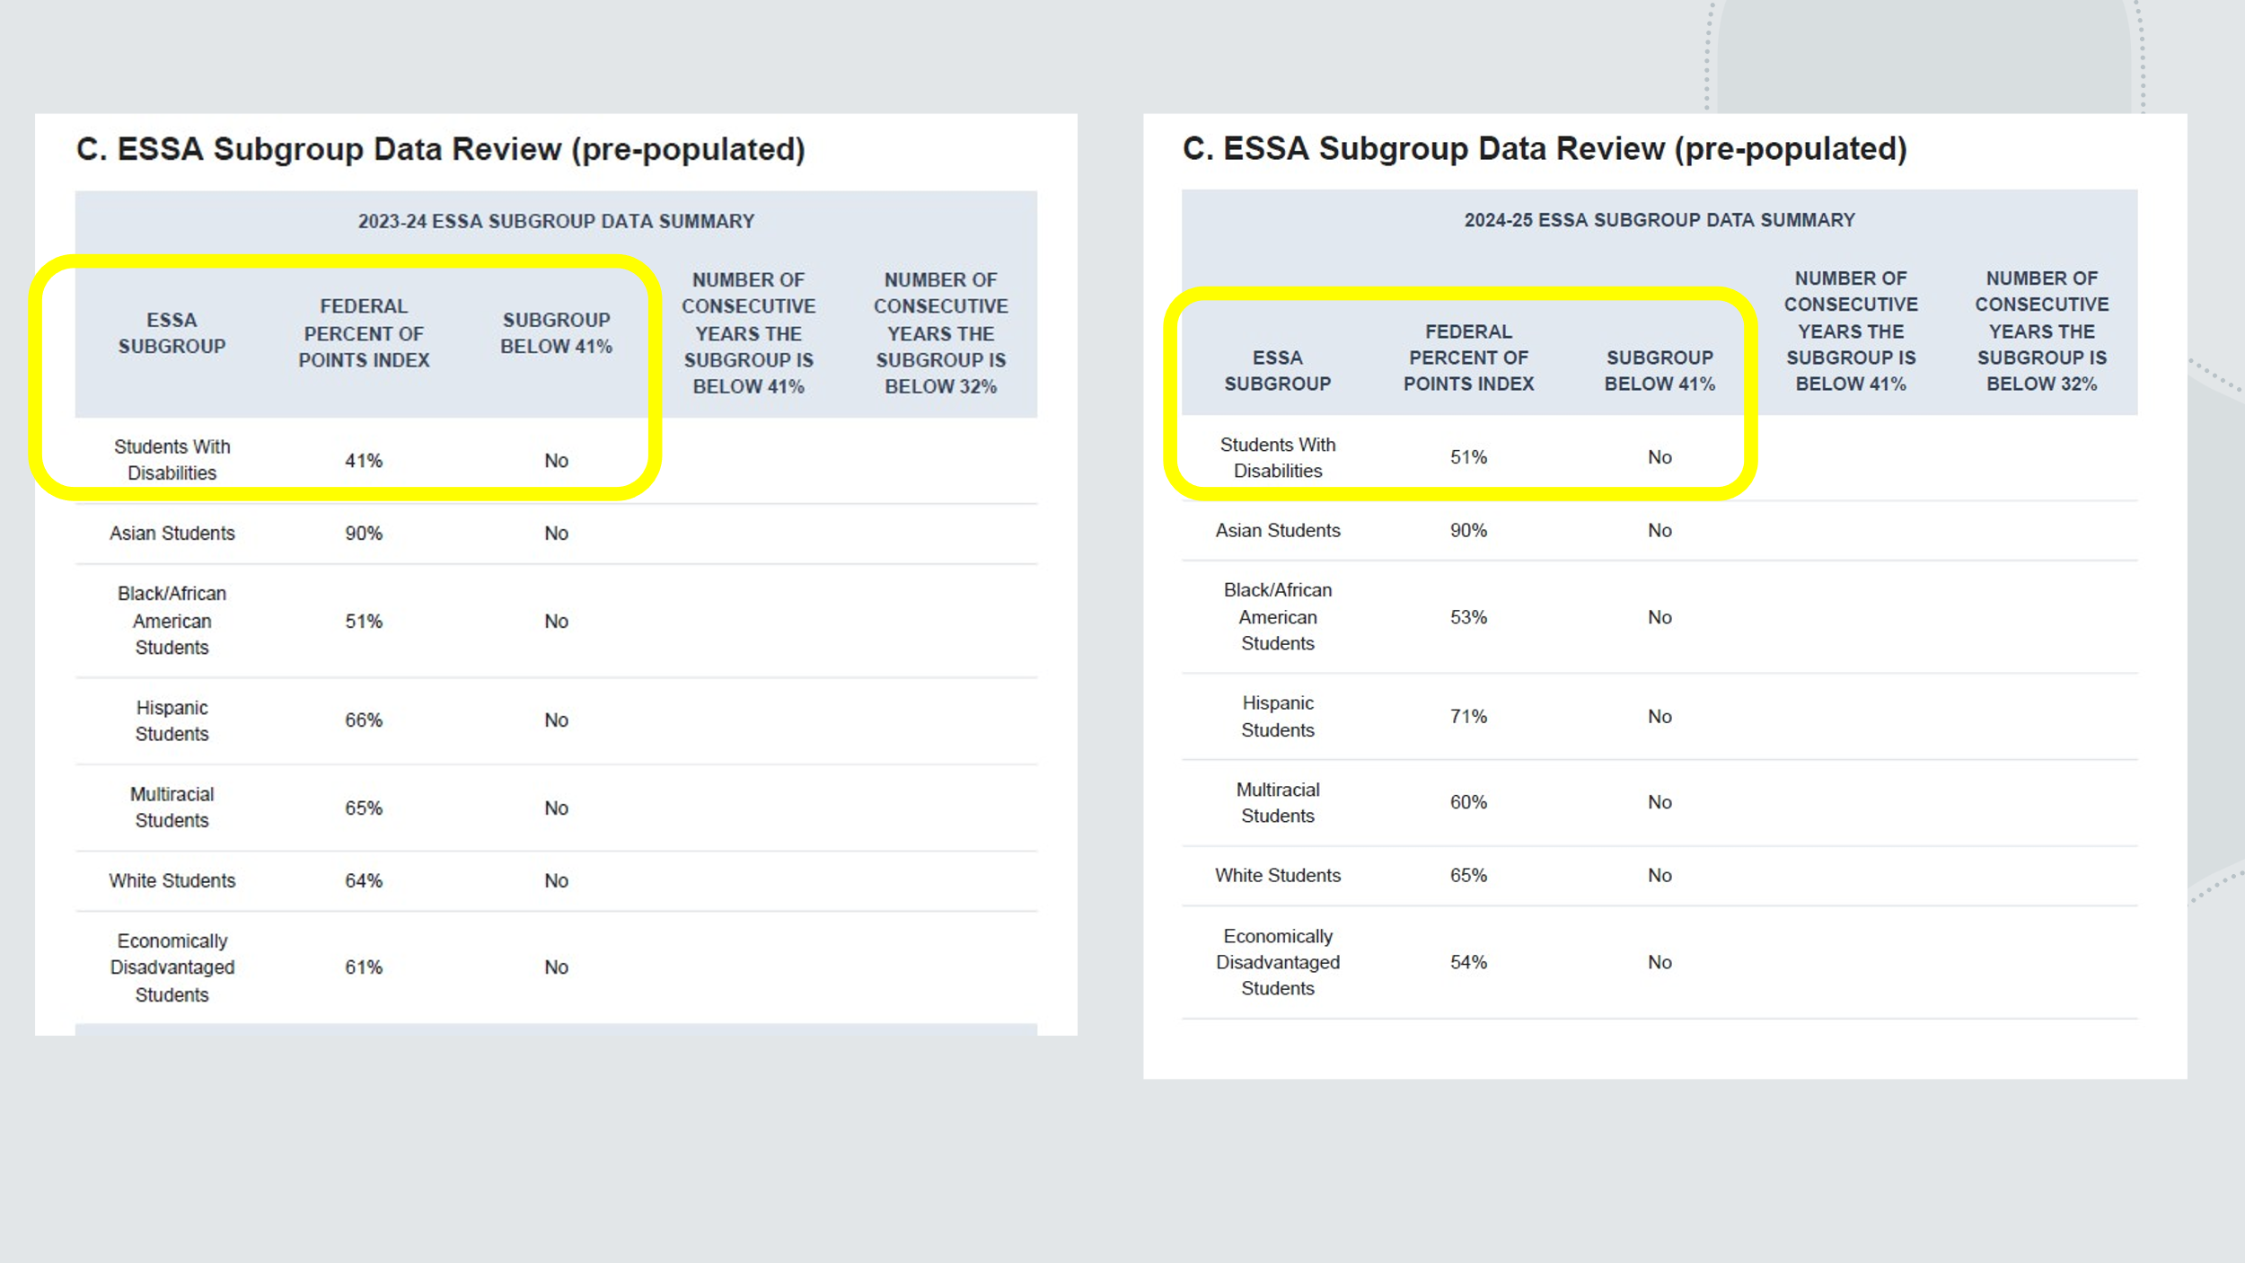

Slide 3
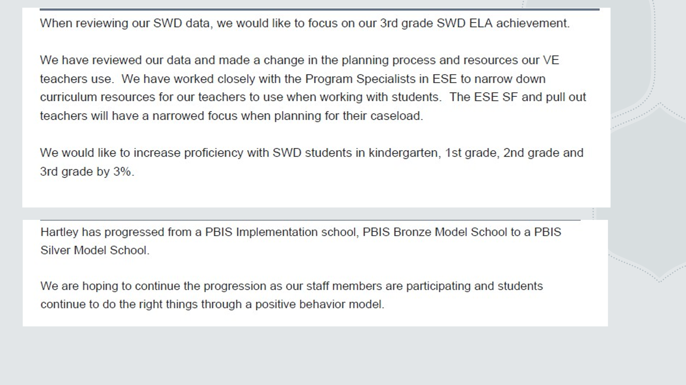

- Other school news
- Fall Festival was a great success
- Career Day: There are a few spots left if anyone would like to participate by presenting their career to the students.
- Community Day and Holiday Shoppe: Ms. Appelquist will be sending out a sign-up sheet for these events.

- Community Connections
- Ms. Lisa Calvert reported that Thursday the SE Branch of the SJPLS will host a “Stuffed Animal Sleepover (the stuffed animals’ sleepover, not the children). Books will be read to the students and stuffed animals and, the children put the “bed” and leave.
There are also many other fun activities going on at the library for school aged children.
She encouraged those present to stop by the library and pick up a calendar of events.
- PTO Report: Ms. Becky Cromwell that a PTO meeting is scheduled for Thursday and that Holiday Grateful Grams will be going on sale soon,

- District Updates – No district updates due to Ms. Jennifer Collins being at a workshop.
There being no further business, Mr. Richard Dow moved to adjourn the meeting, Ms. Kim Arnold seconded the motion. The motion was unanimously approved and the meeting was adjourned at 3:19 p.m.

Respectfully submitted,
Linda Villadóniga, Secretary

